Assignment-4
Software Development Life Cycle and Software Testing Life Cycle

- Explain the various phases of SDLC.

The software development life cycle (SDLC) is a framework defining tasks performed at each step in the software development process.

There are following six phases in every Software development life cycle model:
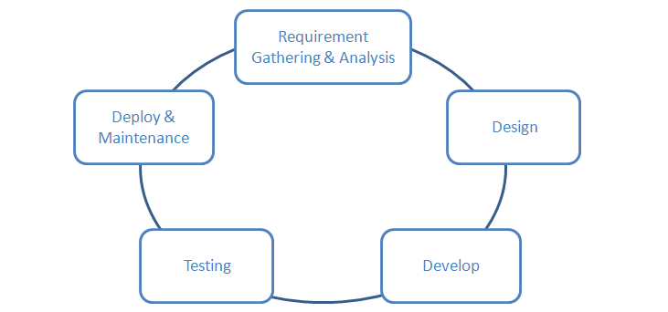
- Requirement gathering and analysis
- Design
- Implementation or coding
- Testing
- Deployment
- Maintenance

Requirement gathering and analysis: Business requirements are gathered in this phase. This phase is the main focus of the project managers and stake holders. Meetings with managers, stake holders and users are held in order to determine the requirements like; Who is going to use the system? How will they use the system? What data should be input into the system? What data should be output by the system? These are general questions that get answered during a requirements gathering phase. After requirement gathering these requirements are analyzed for their validity and the possibility of incorporating the requirements in the system to be development is also studied.
Finally, a Requirement Specification document is created which serves the purpose of guideline for the next phase of the model.

Design: In this phase the system and software design is prepared from the requirement specifications which were studied in the first phase. System Design helps in specifying hardware and system requirements and also helps in defining overall system architecture. The system design specifications serve as input for the next phase of the model.

Implementation / Coding: On receiving system design documents, the work is divided in modules/units and actual coding is started. Since, in this phase the code is produced so it is the main focus for the developer. This is the longest phase of the software development life cycle.

Testing: After the code is developed it is tested against the requirements to make sure that the product is actually solving the needs addressed and gathered during the requirements phase. During this phase all types of functional testing like unit testing, integration testing, system testing, acceptance testing are done as well as non-functional testing are also done.

Deployment: After successful testing the product is delivered / deployed to the customer for their use. As soon as the product is given to the customers they will first do the beta testing. If any changes are required or if any bugs are caught, then they will report it to the engineering team. Once those changes are made or the bugs are fixed then the final deployment will happen.

Maintenance: Once when the customers starts using the developed system then the actual problems comes up and needs to be solved from time to time. This process where the care is taken for the developed product is known as maintenance.

- Explain the various phases of STLC

Software Testing Life Cycle is a testing process which is executed in a sequence, in order to meet the quality goals. It is not a single activity but it consists of many different activities which are executed to achieve a good quality product. There are different phases in STLC which are given below:
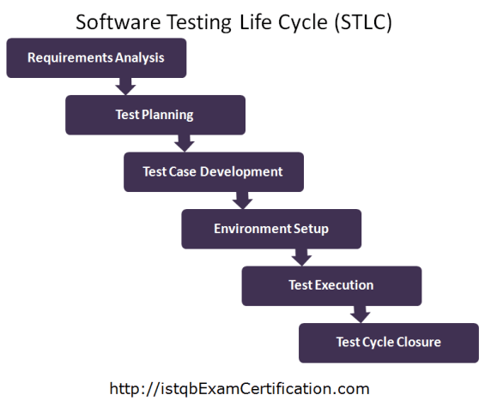

Requirement Analysis
This is the very first phase of Software testing Life cycle (STLC). In this phase testing team goes through the Requirement document with both Functional and non-functional details in order to identify the testable requirements.
Activities to be done in Requirement analysis phase are given below:
- Analyzing the System Requirement specifications from the testing point of view
- Preparation of RTM that is Requirement Traceability Matrix
- Identifying the testing techniques and testing types
- Prioritizing the feature which need focused testing
- Analyzing the Automation feasibility
- Identifying the details about the testing environment where actual testing will be done
Deliverables (Outcome) of Requirement analysis phase are:
- Requirement Traceability Matrix (RTM)
- Automation feasibility report

Test Planning
Test Planning phase starts soon after the completion of the Requirement Analysis phase. In this phase the QA manager or QA Lead will prepare the Test Plan and Test strategy documents. As per these documents they will also come up with the testing effort estimations.
Activities to be done in Test Planning phase are given below:
- Estimation of testing effort
- Selection of Testing Approach
- Preparation of Test Plan, Test strategy documents
- Resource planning and assigning roles and responsibility to them
- Selection of Testing tool
Deliverables (Outcome) of Test Planning phase are:
- Test Plan document
- Test Strategy document
- Best suited Testing Approach
- Number of Resources, skill required and their roles and responsibilities
- Testing tool to be used

Test Case Development
In this phase the QA team write test cases. They also write scripts for automation if required. Verification of both the test cases and test scripts are done by peers. Creation of Test Data is done in this phase.
Activities to be done in Test Case Development phase are given below:
- Creation of test cases
- Creation of test scripts if required
- Verification of test cases and automation scripts
- Creation of Test Data in testing environment
Deliverables (Outcome) of Test Case Development phase are:
- Test cases
- Test scripts (for automation if required)
- Test Data

Test Environment setup

This phase includes the setup or installation process of software and hardware which is required for testing the application. In this phase the integration of the third party application is also carried out if required in the project.
After setting up the required software and hardware the installation of build is tested. Once the installation of build is successful and complete then the Test Data is generated.
After the creation of Test data the Smoke testing is executed on the build in order to check whether the basic functionalities are working fine or not. This phase can be done in parallel with the Test Case Development phase.
Activities to be done in Test Environment Setup phase are given below:
- As per the Requirement and Architecture document the list of required software and hardware is prepared
- Setting up of test environment
- Creation of test data
- Installation of build and execution of Smoke testing on it
Deliverables (Outcome) of Test Environment Setup phase are:
- Test Environment setup is ready
- Test Data is created
- Results of Smoke testing

Test Execution

Before starting the Test Execution phase the Test Environment setup should be ready. In Test Execution phase the test cases are executed in the testing environment.
While execution of the test cases the QA team may find bugs which will be reported against that test case. This bug is fixed by the developer and is retested by the QA.
Activities to be done in Test Execution phase are given below:
- Execution of Test Cases
- Reporting test results
- Logging defects for the failed test cases
- Verification and retesting of the defect
- Closure of defects
Deliverables (Outcome) of Test Execution phase are:
- Test execution Report
- Updated test cases with results
- Bug Report

Test Cycle Closure

In order to start the Test Cycle Closure activity the Test Execution phase should be completed. In Test Cycle phase the QA team will meet and discuss about the testing artifacts.
The whole intent of this discussion is to learn lessons from the bad practices. This will help in future projects.
Activities to be done in Test Cycle Closure phase are given below:
- To evaluate the test completion on the basis of Test Coverage and Software Quality
- Documentation of the learning from the project
- Analyzing the test results to find out the distribution of severe defects
- Test Closure Report preparation
Deliverables (Outcome) of Test Cycle Closure phase are:
- Report of Test Closure.

- Explain Traditional Software Development Model.

The waterfall model is a sequential (non-iterative) design process, used in software development processes, in which progress is seen as flowing steadily downwards (like a waterfall) through the phases of conception, initiation, analysis, design, construction, testing, production/implementation and maintenance.
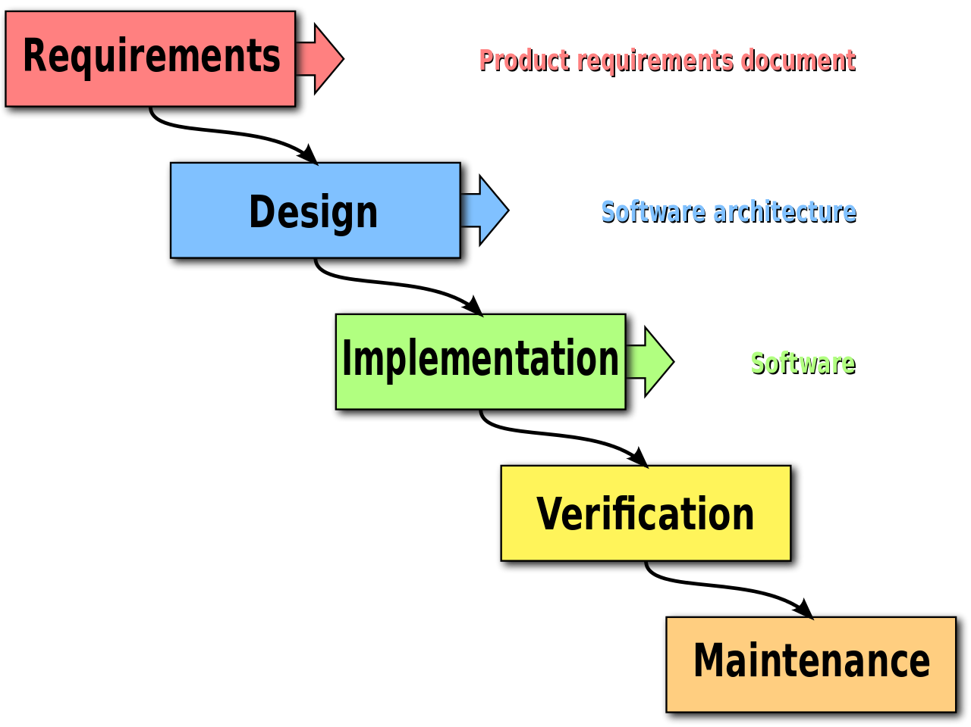

Advantages of waterfall model:
- This model is simple and easy to understand and use.
- It is easy to manage due to the rigidity of the model – each phase has specific deliverables and a review process.
- In this model phases are processed and completed one at a time. Phases do not overlap.
- Waterfall model works well for smaller projects where requirements are very well understood.
Disadvantages of waterfall model:
- Once an application is in the testing stage, it is very difficult to go back and change something that was not well-thought out in the concept stage.
- No working software is produced until late during the life cycle.
- High amounts of risk and uncertainty.
- Not a good model for complex and object-oriented projects.
- Poor model for long and ongoing projects.
- Not suitable for the projects where requirements are at a moderate to high risk of changing.

- Explain Prototype Software development Model.

The Prototyping Model is a systems development method (SDM) in which a prototype (an early approximation of a final system or product) is built, tested, and then reworked as necessary until an acceptable prototype is finally achieved from which the complete system or product can now be developed.

Diagram of Prototype model:
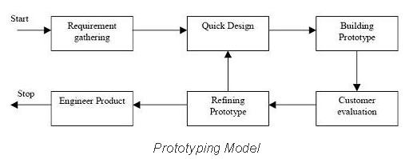
Advantages of Prototype model:
- Users are actively involved in the development
- Since in this methodology a working model of the system is provided, the users get a better understanding of the system being developed.
- Errors can be detected much earlier.
- Quicker user feedback is available leading to better solutions.
- Missing functionality can be identified easily
- Confusing or difficult functions can be identified
Requirements validation, Quick implementation of, incomplete, but
functional, application.
Disadvantages of Prototype model:
- Leads to implementing and then repairing way of building systems.
- Practically, this methodology may increase the complexity of the system as scope of the system may expand beyond original plans.
- Incomplete application may cause application not to be used as the
full system was designed
Incomplete or inadequate problem analysis.

- Explain Iterative Enhancement life Cycle Model

An iterative life cycle model does not attempt to start with a full specification of requirements. Instead, development begins by specifying and implementing just part of the software, which can then be reviewed in order to identify further requirements. This process is then repeated, producing a new version of the software for each cycle of the model.
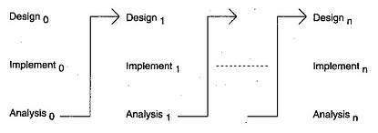
Diagram of Iterative model:

- Explain the various types of Maintenance Phase.

- Corrective maintenance: The set of tasks is destined to correct the defects to be found in the different equipment and that are communicated to the maintenance department by users of the same equipment.
- Preventive Maintenance: Its mission is to maintain a level of certain service on equipment, programming the interventions of their vulnerabilities in the most opportune time. It is used to be a systematic character, that is, the equipment is inspected even if it has not given any symptoms of having a problem.
- Predictive Maintenance: It pursues constantly know and report the status and operational capacity of the installations by knowing the values of certain variables, which represent such state and operational ability. To apply this maintenance, it is necessary to identify physical variables (temperature, vibration, power consumption, etc.

- Zero Hours Maintenance (Overhaul): The set of tasks whose goal is to review the equipment at scheduled intervals before appearing any failure, either when the reliability of the equipment has decreased considerably so it is risky to make forecasts of production capacity.
- Periodic maintenance (Time Based Maintenance TBM): the basic maintenance of equipment made by the users of it. It consists of a series of elementary tasks (data collections, visual inspections, cleaning, and lubrication, retightening screw) for which no extensive training is necessary, but perhaps only a brief training. This type of maintenance is the based on TPM (Total Productive Maintenance).

- What is the deference between High Level design and Low Level design?

HLD- also known as macro level/ system design...
LLD- also known as micro level/ detailed design...
HLD- 2 main components are 1>Functional architecture of application... 2>Database design...
LLD- in this design, for every program logic design is done, documented and unit test plan created...
HLD- participants are design team, review team and client...
LLD- participants are only design team...
HLD- input criteria is Software Requirement Specification (SRS)... Output criteria is database design, functional design and review record...
LLD- input criteria is HLD, which are reviewed and authorized... An output criterion is Program specification and unit test plan.

- Explain V-Shaped Model.

V- Model means Verification and Validation model. Just like the waterfall model, the V-Shaped life cycle is a sequential path of execution of processes. Each phase must be completed before the next phase begins. V-Model is one of the many software development models. Testing of the product is planned in parallel with a corresponding phase of development in V-model.

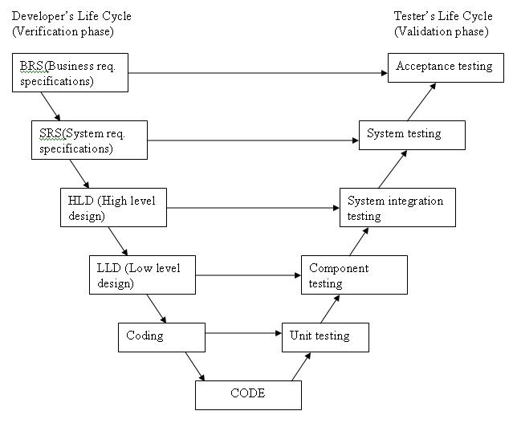

- What is the difference between functional spec. and Business requirement specification?

Business Requirement documents have information about what all information an end user or business user wants to see on the application and how he would like to make maximum and optimum use of it.

A functional specification (also, functional spec, specs, functional specifications document (FSD), functional requirements specification, or Program specification, or Product Requirement Document "PRD") in systems engineering and software development is the documentation that describes the requested behavior of an engineering system. The documentation typically describes what is needed by the system user as well as requested properties of inputs and outputs (e.g. of the software system)

- What is the difference between Testing and debugging?

